Output for Forest Combustion:

Predicted as forest fire image

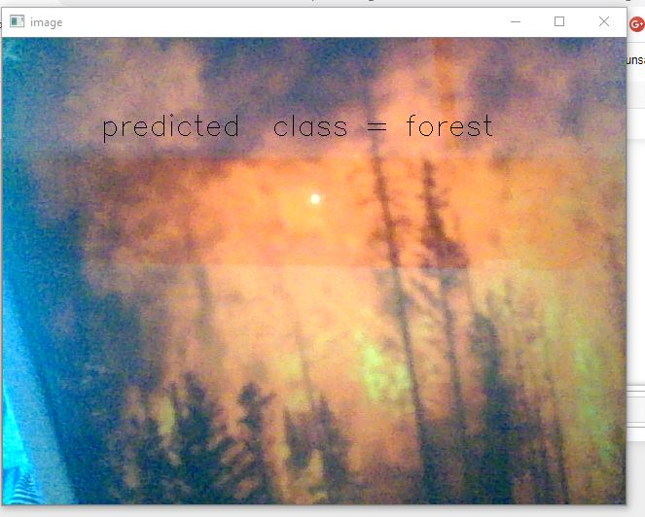

Program output when fire was detected



Email send when fire was detected

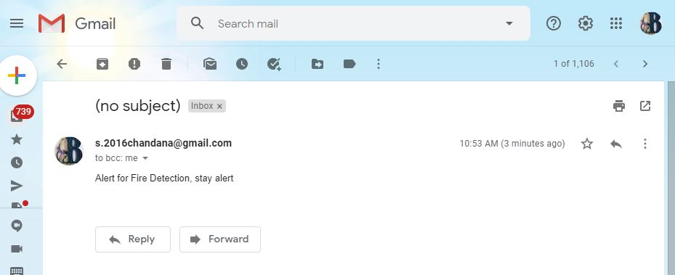

2. Predicted as forest without fire

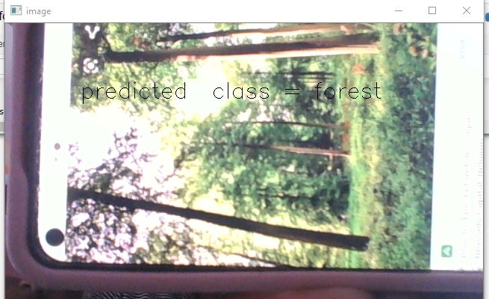

Program output for no fire

